**Project 5: Render Your Scene With Primitives**

Adrian Tudur, Omar Elsayd, and Haley Hansen

Grand Canyon University

CST: 310

Professor Citro

October 16, 2022

**Project 2 -Your Surrounding World**

**Project Description/Approach:**

In this project we are asked to provide at least six pictures, two per scene, for the image we will re-create utilizing OpenGL. We first discussed ideas regarding our scene, ensuring that we don’t make it too complicated nor too easy. We each provided a scene, with at least two different angles. Now it is up to our professor to choose the one that we utilize for the future projects.

We wanted to make sure that we don’t involve too much material or an odd texture that becomes too difficult to remake in OpenGL. Essentially, we want this to be attainable, so that we don’t fall behind as we progress throughout the semester. Additionally, we are going to utilize scenes that resemble general polygons, as OpenGL contains already built in functions that construct these shapes.

**Pictures:**

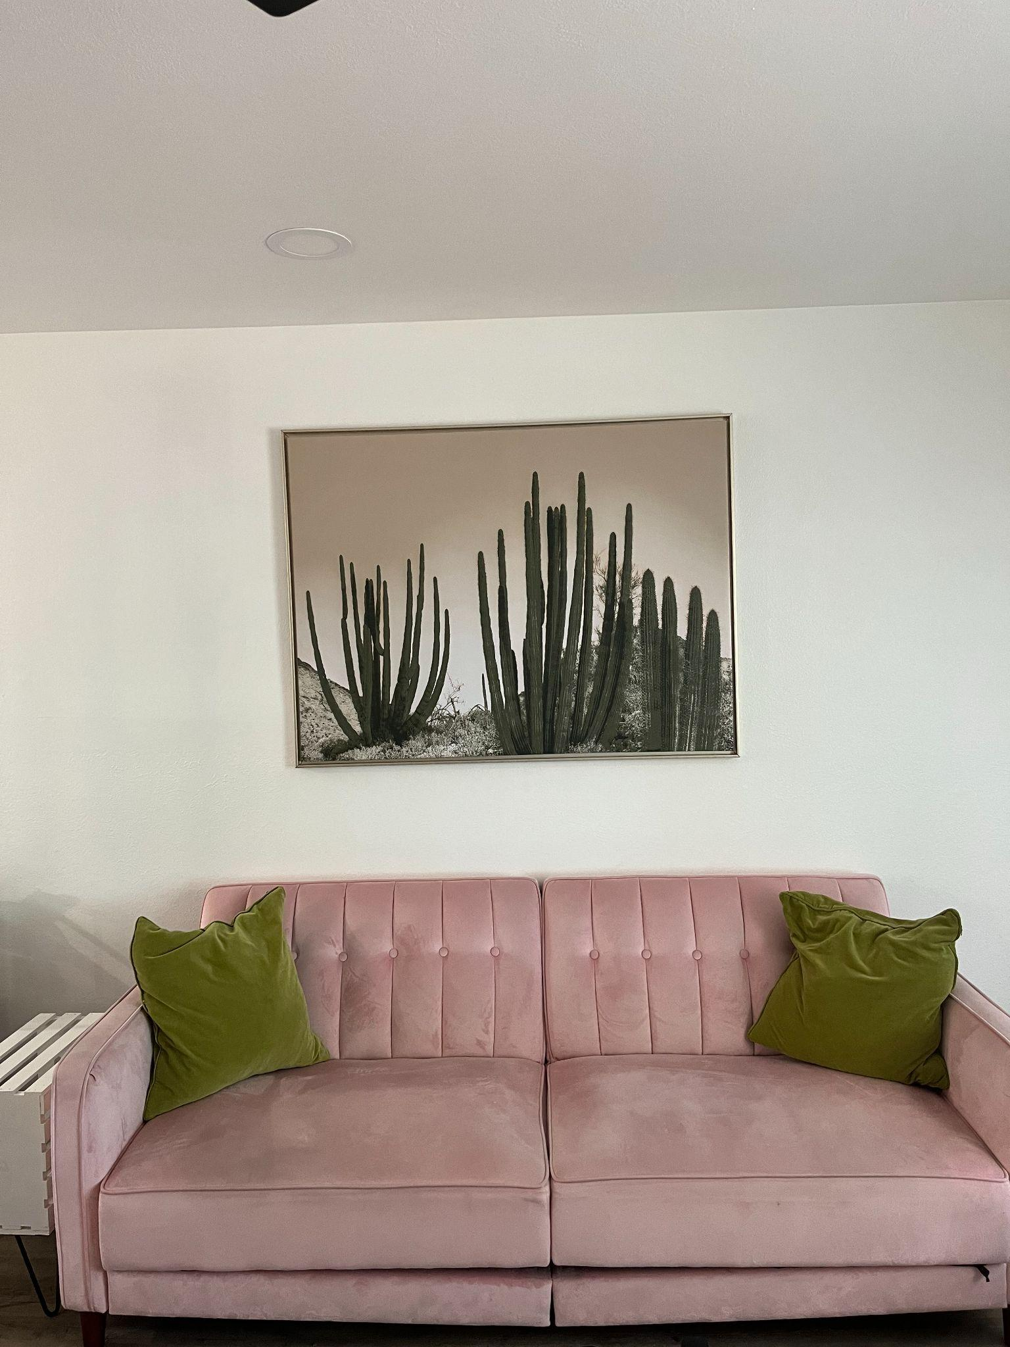

Above is a picture conveying a pink tufted couch, accompanied by two green pillows. Above the couch is a picture of cacti. The wall holding the picture is all white. The floor is wooden vinyl and on the left of the couch is a white side table made out of a crate.

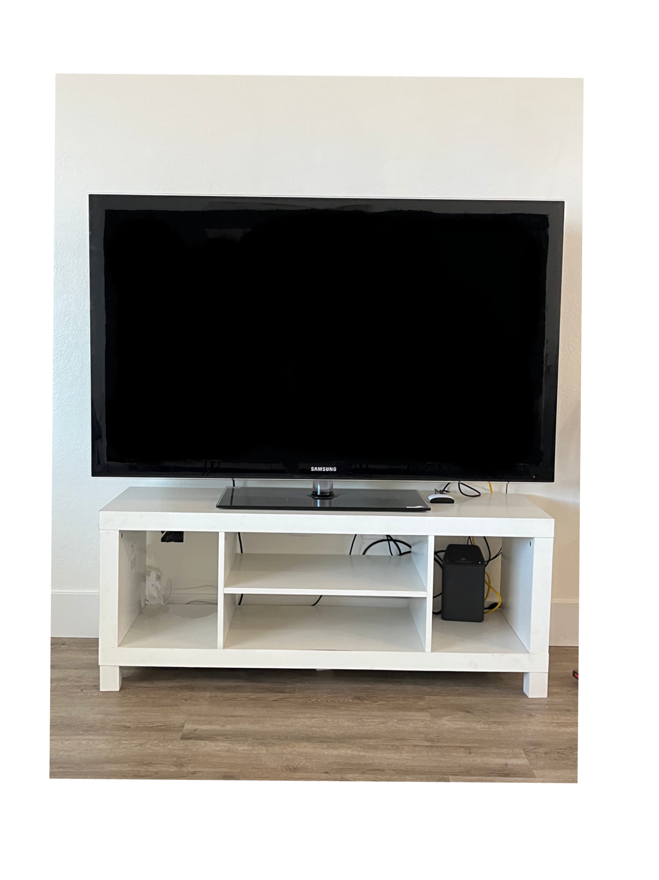

The picture above displays a large black flat screen tv on top of a white tv stand. There are different sections of the tv stand for organizing objects or baskets. There is an internet router on the bottom right shelf. The wall behind is all white and the floor is a light wooden vinyl.

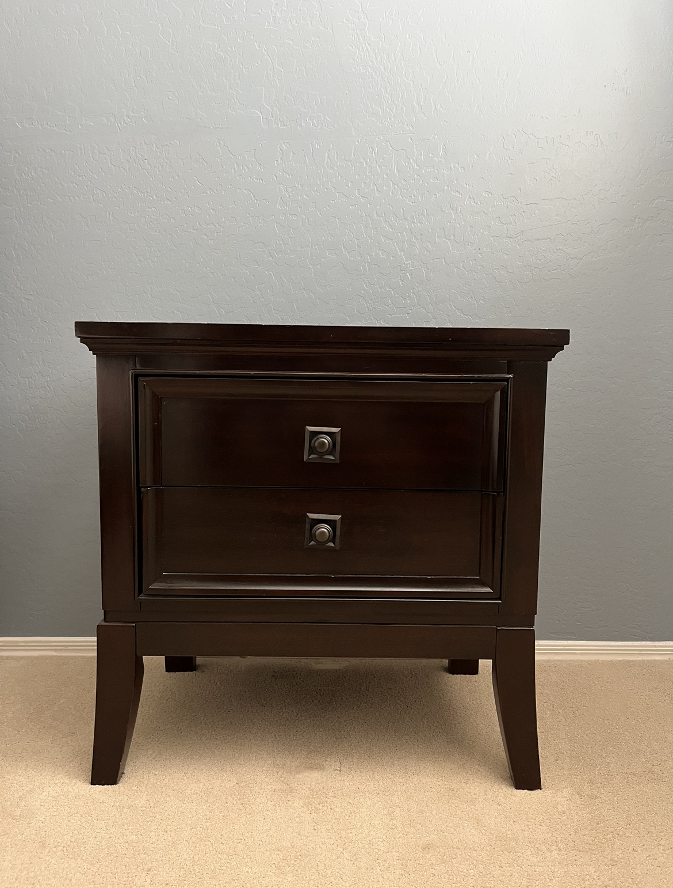

The picture above displays a night stand that is in a bedroom. The night stand is placed next to a gray wall with it being on carpet. The cabinet has details on the drawers and has details on the knobs of the night stand.

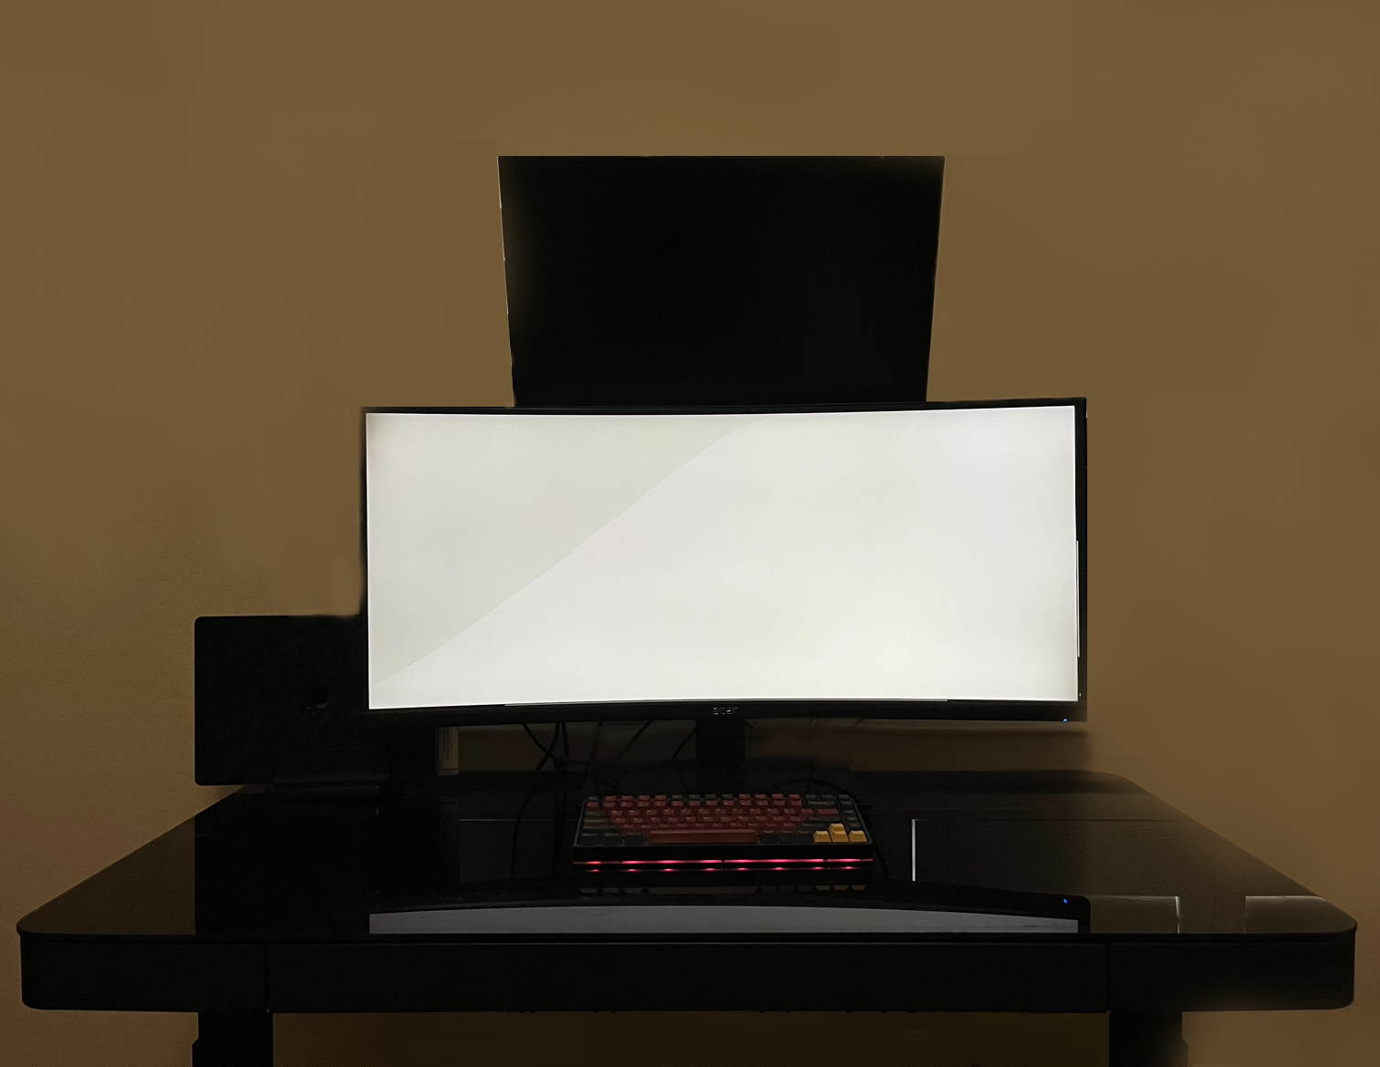

The picture above displays my desk with my two monitors and laptop. In the picture it has the desk with the keyboard on it. It has two monitors and a computer next to the bottom monitor.

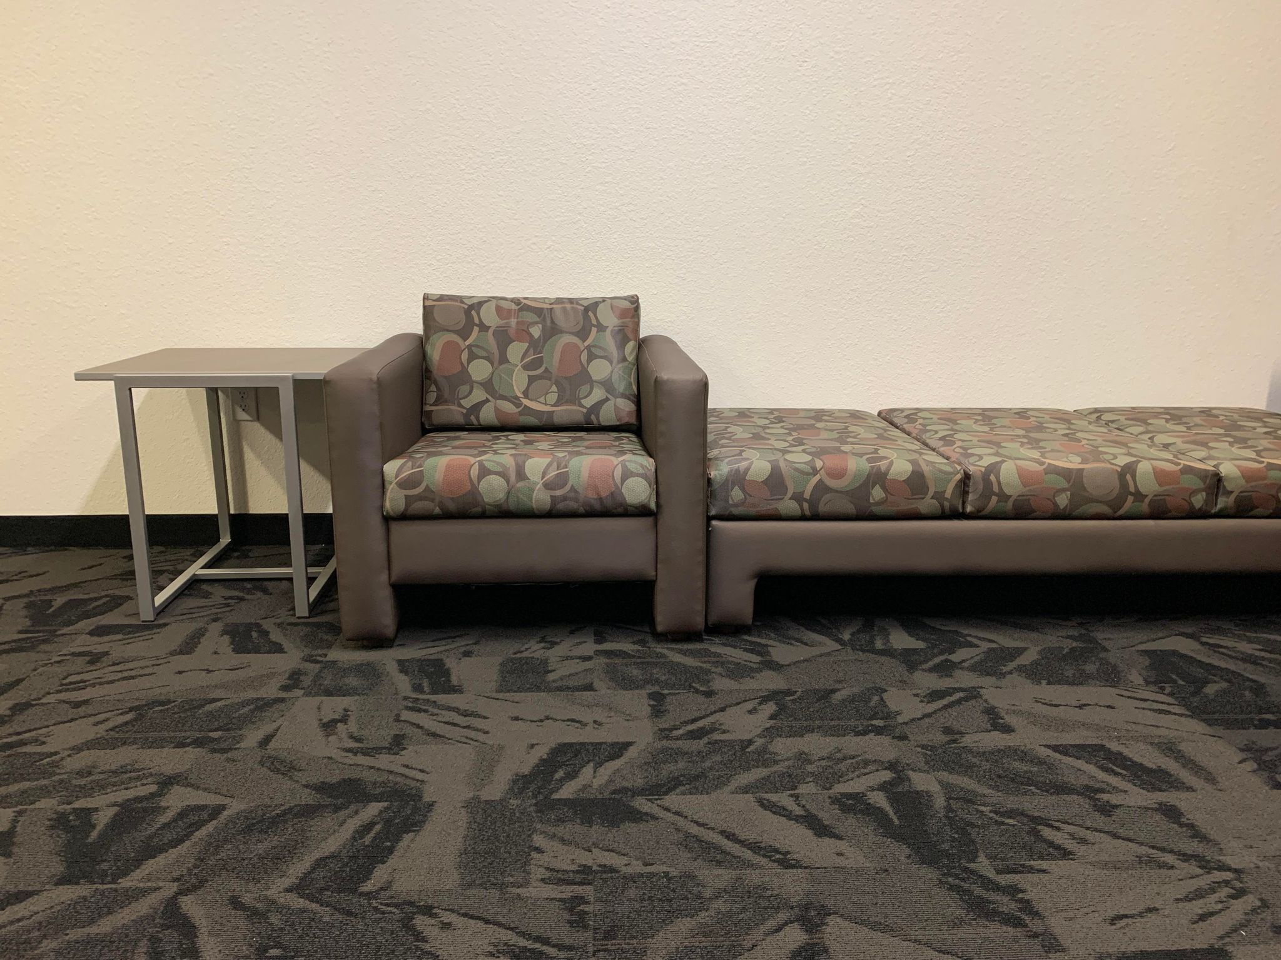

This is a picture from the dorm floor of a chair, couch, and a table. The floor has a specific pattern. The pattern displayed on the chair and bench are the same.

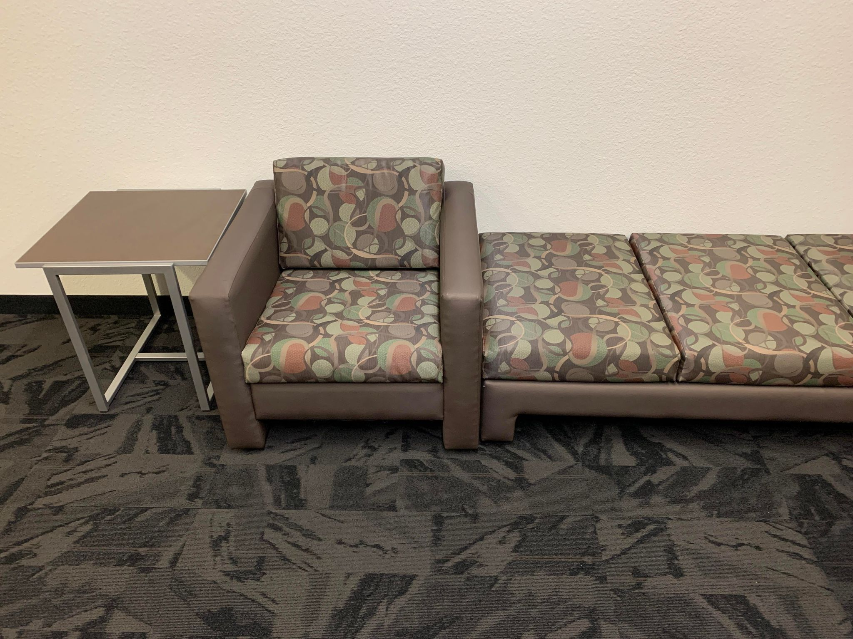

Here is another angle from the same setup above, set at a higher angle than the previous shot of this scene.

**Picture Certification Statement:**

The pictures we provided in this document are all from the students in this group. They were taken with a basic Apple Iphone camera. They are original and did not come from the internet.

**Project 3: Your Surrounding World (cont)**

**Objects/Main Objects:**

Our main objective of this project is replicate first the scene on paper and then implement and render the scene in openGl. Tha main objects we have here are:

* Couch
* Chair
* Small table

It is important for us to break down the object into geometrical shapes in order to be able to implement it as showing below in the examples

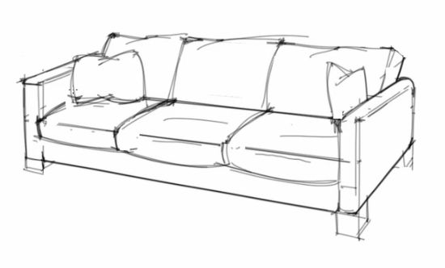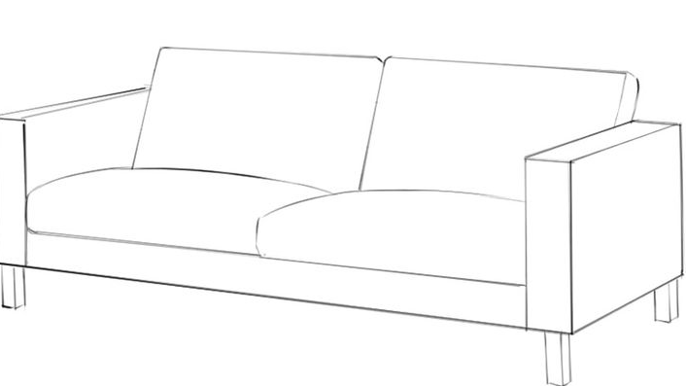

**Key characteristics of the scene:**

As we mentioned in the previous point, we need to break down the objects into geometrical shapes and then map that to the object. For example, the chair will be a collection of squares and rectangles.

**Scene Approach:**

Our approach will depend on which object first we will be able to break down and make its geometrical shapes. In other words, it looks like the small table is easy to break down and map its small rectangle. As shown below. We did analysis of the object and its dimension and then broke that into geometrical shapes. In the example below, we broke down the object into rectangles and parallelograms.

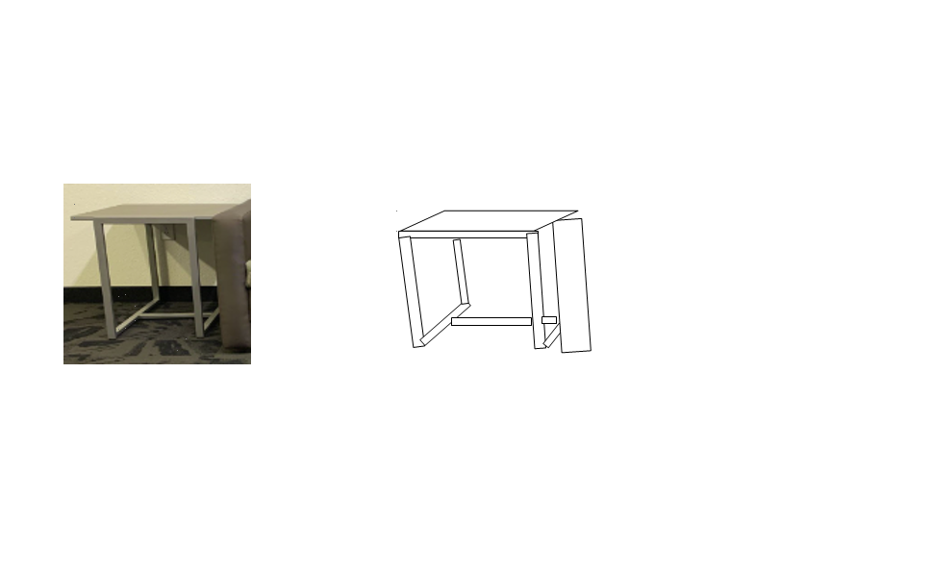

**Ranking Object Difficulty (scale 1-10):**

The hardest object would be the couch which would be a 7. Next would be the bench which would be a close 6. Lastly would be the table which would be a 4. The reason for the ranking is because the couch has the most detail and shapes. The couch has arm rests and two pillows. The bench is the second hardest because it has three of the same sized pillows and the legs. The bench also has a similar amount of detail as the couch has which makes it similar in difficulty Lastly the table would be the easiest because the legs are simple with no detail. The top of the table is also plain and just a square.

**Geometrical Representation:**

Below is a geometrical representation of our scene. It was drawn on white printer paper, drawn with pencil, then outlined in pen ink.

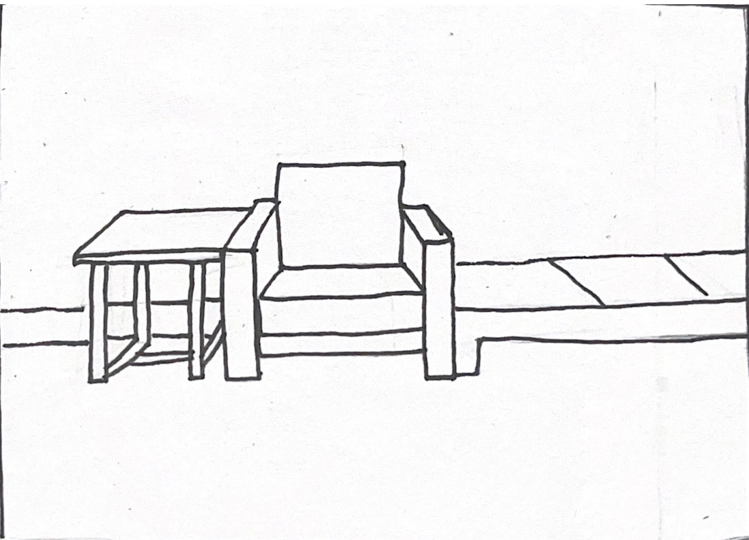

Original vs Representation (side by side):



The two pictures above show both the original representation (on the left) versus the geometrical representation (on the right).

**Project 4 - Render Your Scene with Primitives**

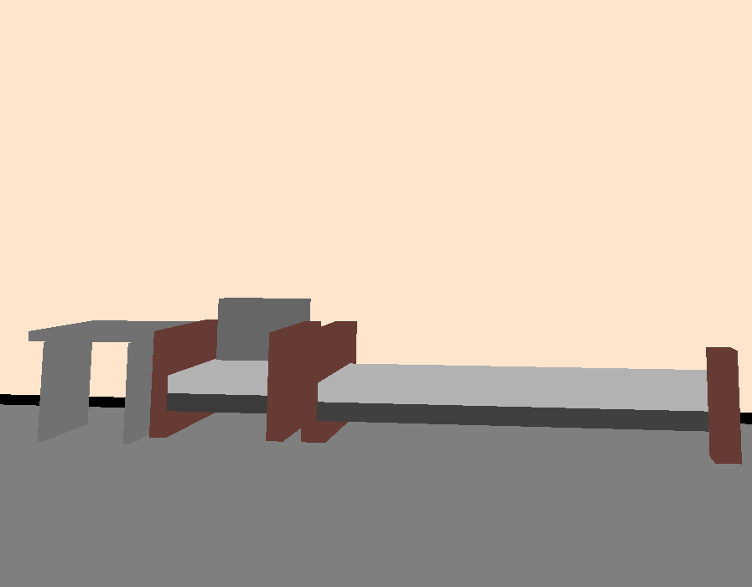

**Virtual Camera Position Used:**

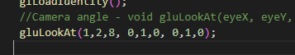

**Object 1 - Bench**

Mathematical characteristics:

Two horizontal rectangles and vertical rectangles

Primitives:

Rectangles

Transformations:

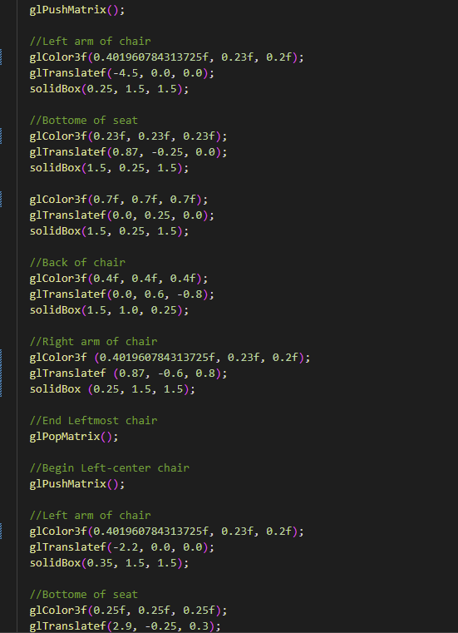

Shader used:

We used glcolor3f()

Screenshots:

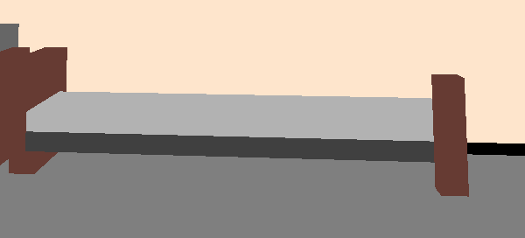

**Object 2 - Chair**

Mathematical characteristics:

Two horizontal rectangles and vertical rectangles

Primitives:

Rectangles

Transformations:

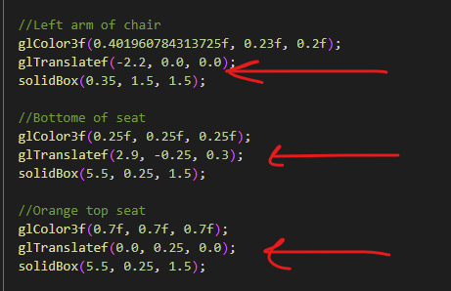

Shader used:

We used glcolor3f() for every single shape

Screenshots:

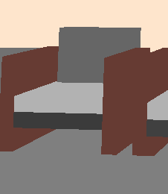

**Object 3 - Table**

Mathematical characteristics:

1 Horizontal rectangle and two vertical rectangles

Primitives:

Rectangles

Transformations:

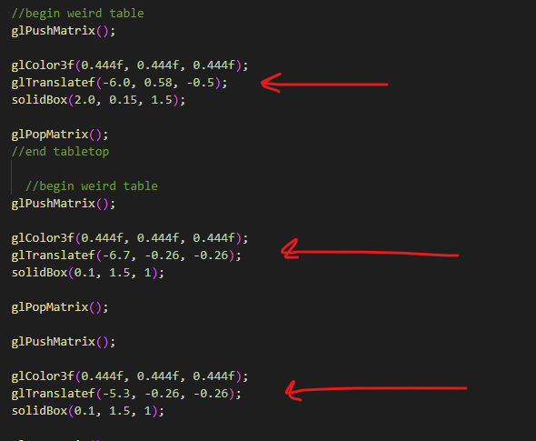

Shader used:

We used glcolor3f() for every single shape

Screenshots:

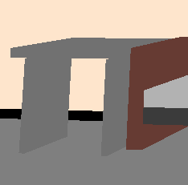

Project 5 - Render your Scene with Primitives

Github Link: <https://github.com/OmarElsayd/CST-310Repo>

Improvements to each object

1. Mathematical characteristics
2. The primitives used to render
3. All the transformations used and explanations on their use
4. The shader(s) used and explanations of the reasoning and what it accomplished